|  |
| --- |
| MEEM 5290 INTERNAL COMBUSTION ENGINES |
| Ideal cycles and cycle simulation |
| Assignment 03 |
| **Arjun Darbha** |
| **10/14/2013** |



Introduction

Thermodynamic analysis of the engine helps to estimate various performance parameters of the engine by solving thermo-chemistry equations and knowing the inlet state of the air intake into the engine cylinder. Though the actual processes occurring in the cylinder are complex to analyze with turbulent conditions and non-homogeneous mixtures, certain assumptions can be made which provide an insight into the actual working and also provide an estimate of the engine working parameters like imep, volumetric efficiency, ignition duration, mechanical efficiency etc. The thermodynamic calculations in this work are done in Engineering Equation Solver and the cycle analysis is done in EngineSim, a GUI designed in MATLAB, developed by Prof. Dave Checkel and Kevin Frank of University of Alberta. EngineSim simulates the thermodynamic cycle executed by the IC-Engine assuming isentropic compression and expansion and assuming a Wiebe function for simulation of mass fraction burn. Mass fraction burn is formulated as a function of heat added per crank angle rotation. Imep and efficiencies are later estimated using the data generated by EngineSim.

**Part 1: Equations and problem set-up**

1.1 Gross and net IMEP

Mean effective pressure (MEP) is the work done per unit cycle divided by the cylinder volume displaced. It can be generally defined as

|  |  |  |
| --- | --- | --- |
|  | $$mep=\frac{Pn_{R}}{V_{d}N}$$ |  |

where

* P is the power of the engine
* nR is 2 for 4S engine
* Vd is the volume displaced
* N is rotation in rps

When P is calculated from cycle parameters, mep is called the indicated mep. In case of a real engine, there is pumping work involved during exhaust or intake strokes. The pumping mean effective pressure-pmep is a positive quantity defined as

|  |  |  |  |  |  |
| --- | --- | --- | --- | --- | --- |
|  | |  |  |  | | --- | --- | --- | |  |  |  | |  |
|  |  |  |

where pi and pe are the pressures at intake and exhaust respectively.

The mep calculated from equation 1 is the gross mean effective pressure. Pumping losses have to be removed from this value to obtain the net mean effective pressure. Hence,

|  |  |  |
| --- | --- | --- |
|  | $$imep_{n}=imep_{g}- (p_{e}-p_{i})$$ |  |

1.2 Volumetric efficiency

The air intake into the engine cylinder is restricted by various components in the engine cylinder, like carburetor, throttle valve etc. Volumetric efficiency is a parameter which helps to estimate effectiveness of the engine induction process. Volumetric flow rate is defined as the ratio of flow rate of air in the intake system to the volume of engine displaced.

|  |  |  |
| --- | --- | --- |
|  | $$η_{v}=\frac{r_{c}\left(1-x_{r}\right)}{v_{1}ρ_{a}\left(r_{c}-1\right)}$$ |  |

where

* rc is the compression ratio
* xr is the mass fraction of residuals
* v1 is the specific volume of the mixture
* $ρ_{a}$ is the inlet air density

Volumetric flow rates for NA engines are usually in the range of 80-90%. It is higher in the case of CI engines when compared to SI engines. Also, it should be noted that volumetric efficiency is defined only for a 4S engine

1.3 Fuel conversion efficiency

Fuel conversion efficiency is defined as alternative to specific fuel consumption. As the latter has units, it becomes imperative that a dimensionless parameter be defined which allows comparison of different engines irrespective of their scale and size. Fuel conversion efficiency is defined as the ratio of work produced from cycle to the amount if fuel energy supplied per cycle that can be released by combustion. The combustion heat released is a fuel specific value called Qlhv

|  |  |  |
| --- | --- | --- |
|  | $$η_{f}=\frac{P}{ \dot{m_{f}Q_{LHV} }} and {η_{f}}_{in,net}={η_{f}}_{gross}(1-\frac{p_{e}-p_{i}}{imep})$$ |  |

where

* P is the work done by the engine per unit second
* $m_{f}$ is the mass flow rate of fuel intake
* $Q_{lhv}$ is the lower heating value of the fuel

Power is directly obtained from the work-done by cycle which can be deduced from a thermodynamic cycle. This value is close to the actual efficiency of the engine. It is one of the important parameters that can be obtained by performing cycle analysis on the engine. Fuel conversion net

1.4 Thermochemistry Equation

The chemical equation used for the solution is illustrated in equation 7

|  |  |  |
| --- | --- | --- |
|  | $$CH_{HCR}O_{OCR}S_{SCR}N_{NCR}+ λ\left(1+\frac{HCR}{4}-\frac{OCR}{2}+ SCR+\frac{NCR}{2}\right).\left(O_{2}+ 3.728N_{2}+0.045Ar+0.002CO_{2}+{N_{moles}}_{H_{2}O}H_{2}O\right)+ N_{residuals}\left(residuals\right)→Products$$ |  |

In this equation, number of moles of H2O on the reactants side is decided by the relative humidity of air. This number can be evaluated using the following equation

|  |  |  |
| --- | --- | --- |
|  | $$N_{H_{2}O}=1.608*4.775*ω$$ |  |

Here $ω$ is the absolute humidity and its value can be calculated by using Relative Humidity (RH) value which has been specified as a part of the problem statement. Its value is given by equation 9

|  |  |  |
| --- | --- | --- |
|  | $$ω=\frac{0.622ϕP_{g}}{P-ϕP_{g}}$$ |  |

where

* $ϕ$ is the value of RH
* $P_{g}$ is the saturation pressure as a function of temperature
* $P$ is the atmospheric pressure

1.5 Solution formulation

The solution is formulated in following steps for each case presented in the Table 1

* Calculation of xr and T1 – These values are calculated from Section 5.5 of Heywood using equations 5.47 and 5.48.

|  |  |  |
| --- | --- | --- |
|  | $$x_{r}={\left\{1+\frac{T_{r}}{T_{1}}\left[r_{C}\left(\frac{p_{i}}{p_{e}}\right)-{\left(\frac{p_{i}}{p_{e}}\right)}^{γ-\frac{1}{γ}}\right]\right\}}^{-1}$$ |  |
|  | $$T_{1}=T_{r}r_{c}x_{r}(\frac{p_{i}}{p_{e}})$$ |  |

where

* $x_{r}$ is the mass fraction of residuals in the intake
* $T_{r}$ is the temperature of residuals which is estimated to be 1400K
* $r_{c}$ is the compression ratio which is 10 for tie Ford eco-boost engine
* $\frac{γ-1}{γ}$ is estimated to be about 0.24
* $\frac{p_{i}}{p_{e}}$ is the ratio of intake and exhaust pressures, which is estimated to be 1 as it is assumed that there is no turbo-charging and boosting of the intake
* $T_{1}$ is the temperature of the air-residual mixture

* Calculation of actual air and fuel –The chemical equation is solved in order to obtain the actual mass of air and mass of fuel. As the value of $λ$ is known, the value of mass of air can be calculated. Solving the thermo-chemistry equation provides the value of A/F ratio for the stoichiometric reaction. The following assumptions are made for calculating the mass of air
* Air enters the cylinder at MAP
* The temperature of air entering the cylinder is 298K

From the ideal gas-equation,

|  |  |  |
| --- | --- | --- |
|  | $$P_{air}V_{air}=m_{air}RT_{air}$$ |  |

In equation 12, pressure and temperature of the air are assumed to be known, but it has two unknowns in terms of volume and mass. From Amagat’s law, ratio of partial volumes is equal to ratio of number of moles of constituents. This leads to

|  |  |  |
| --- | --- | --- |
|  | $$\frac{V_{air}}{V_{r}}=\frac{n_{air}}{n_{r}}$$ |  |
|  | $$\frac{V_{air}}{V_{r}}=\frac{\frac{m_{air}}{m_{r}}M_{r}}{M_{air}}$$ |  |

In equation 14, $M_{r}, M_{air}$ can be calculated from the balanced chemical equation. The value of $\frac{m_{air}}{m_{r}}$ can be calculated from $x_{r}$ by using equation 15

|  |  |  |
| --- | --- | --- |
|  | $$\frac{m_{r}}{m_{r}+m_{air}}=x_{r}$$ |  |

hence the only unknown in equation 14 is the ratio $\frac{V_{air}}{V_{r}}$. The value of total volume occupied by these partial volumes is also known to be the total volume of the cylinder which is a known quantity

|  |  |  |
| --- | --- | --- |
|  | $$V_{air}+ V_{r}=3.89L$$ |  |

From equations 14 and 16 $V_{air}$ can be calculated. Equation 12 can now be solved to obtain the value of ${ m}_{air}$. As the value of $m_{air}$ is known, the value of $m_{fuel}$ follows as $λ$ is known. The EES code for solving these equations is attached in Appendix A.

* Calculation of mass of water in air from relative humidity (RH): The case for which relative humidity is present is solved by calculating absolute humidity from the given values of relative humidity. Absolute humidity is given by the following equation

|  |  |  |
| --- | --- | --- |
|  | $$ω=\frac{0.622ϕP_{g}}{P-ϕP_{g}}$$ |  |

where

* $ω$ is absolute humidity
* $ϕ$ is relative humidity
* $P_{g}$ is saturation pressure for a particular temperature T
* $P$ is the actual pressure of air

As the $ω$ is known from equation 17, it mass of water-vapor can then be calculated from equation 18

|  |  |  |
| --- | --- | --- |
|  | $$ω=\frac{m_{w}}{m_{air}}$$ |  |

The mass of air to be injected into the cylinder is estimated from equation 12. Therefore, mass of water, and hence the number of moles in water can be calculated. It should also be realized at this point that additional moles of water entering the cylinder do not play any role in ideal combustion process. Hence, like Nitrogen, humidity is considered inert for this analysis. If RH factor is present in the air, water is added to air and residuals separately and analyzed. This is reflected in the part of the code which comments $m_{H_{2}O}$

* Calculation of number of moles of fuel – As mass of air is known and $λ$ is known; (A/F) is known. Mass of fuel can be calculated from this ratio and number of moles of fuel can also be calculated as analysis done in EES is on molar basis. As the Stoichiometric equation is evaluated using equation 7, number if moles of air is determined and corresponding number of moles of products is also determined. It is assumed that mole fraction of products would remain same even after the exhaust. Hence,

|  |  |  |
| --- | --- | --- |
|  | $$N_{air}=m_{air}/M_{air}$$ |  |

and,

|  |  |  |
| --- | --- | --- |
|  | $$N_{r_{i}}=x_{r}*N_{p_{i}}$$ |  |

where $N_{r_{i}}$ is number of moles of residuals and ${N_{p}}_{i}$ is number of moles of products.

As the cylinder is filled with air, $N_{air}$ moles of air gets mixed with $∑{N_{r}}_{i}$ moles of residuals. Hence the mole fractions of air and residuals in the mixture can be calculated.

* At this point value of T1a and xr can be filled into the table. For calculation of T1b, fuel injection needs to be considered. Fuel injected into the cylinder is in the liquid state and it needs energy to change into vapor phase. This energy can either come from the combustion chamber or the charge gas or both. As the problem statement describes let xfv be the fraction of energy supplied by the gas phase and 1-xfv be the energy supplied by combustion chamber. If xfv is 0, all the energy comes from the chamber and if it is 1, energy comes from charge gas. From first law of thermodynamics, following can be obtained,

|  |  |  |
| --- | --- | --- |
|  | $$x_{fv}n_{fuel}*\left(Heat_{vapo{rization}_{fuel}}\right)=N_{charge}Cv_{charge}\left(T_{b}-T_{inter}\right)$$ |  |

In this equation heat of vaporization for different fuels is obtained from table D4 of Heywood. Ncharge is evaluated by summing up equations 19 and 20. Cvcharge is calculated by evaluating each mole-fractions of each component of charge gas and calculating Cv as

|  |  |  |
| --- | --- | --- |
|  | $$Cv_{mix}=∑x_{i}Cv_{i}$$ |  |

where xi is mole fraction of each component and Cvi is its corresponding Cv in kJ/mol-K.

Tinter is the value of intermediate temperature which the charge gas attains after providing required heat of vaporization to the charge gas. It has to be noted that this value is not the mixture temperature

* Calculation of mixture temperature – Now mixture temperature is evaluated using Tinter calculated from previous step using the following equation

|  |  |  |
| --- | --- | --- |
|  | $$N_{fuel}Cv_{fuel}\left(T_{b}-T_{sat}\right)=N_{charge}Cv_{charge}(T_{inter}- T_{b})$$ |  |

Tsat is the saturation temperature of fuel which is assumed to be 25C for this work as standard conditions are assumed for fuel intake. Tinter is calculated from equation 22. Tb is the final temperature of the mixture

* Calculation of Tcomp, Cp, Cv and $γ$– It is assumed that compression from this state to the compressed state is isentropic. Temperature and pressure of air-fuel mixture at this state are known (Pressure is calculated from equation of state, PV=nRT. Volume of the cylinder, temperature of charge and number of moles in charge are known, subsequently, P can be obtained). As entropy is a function of temperature and pressure, entropy of air-fuel mixture at this state can be calculated. At the compressed state, entropy is again a function of temperature and pressure

|  |  |  |
| --- | --- | --- |
|  | $$S_{c}=f(P_{c},T_{c})$$ |  |

where c denotes compressed states

Also from equation of state

|  |  |  |
| --- | --- | --- |
|  | $$P_{c}V_{c}=nRT_{c}$$ |  |

Vc is known in equation 25 as this is the compressed volume of the cylinder at CA0. Therefore in equations 24 and 25, Pc and Tc are the only unknowns which can be solved for simultaneously in EES. As values of Pc and Tc are calculated, Tcomp is just an average of Tb and Tc. Cp and Cv and hence gamma are calculated at this temperature. Pressure used in these calculations doesn’t have a huge impact on the outcome of $γ$ hence any value between the states can be used.

* Calculating heat input – Heat input (qin) is calculated using equation 26

|  |  |  |
| --- | --- | --- |
|  | $$q_{in}=\frac{m_{fuel}\left(Q_{lhv}\right)}{m_{air}+m_{fuel}+m_{r}}$$ |  |

where Qlhv is obtained from table D4 of Heywood. Masses in the equation have already been evaluated in previous steps. This is one of the input parameters for the simulation.

* Simulation of the cycle and obtaining remaining parameters – Cycle simulation in EngineSim requires qin, Cp, Cv, ignition start and burn duration. Burn duration and CA50 values are provided in the table. Ignition start point has to be calculated by using these parameters in the Wiebe function demonstrated by equation 27

|  |  |  |
| --- | --- | --- |
|  | $$x_{b}= 1-exp⁡\{-2.303{\left(\frac{θ-θ_{0}}{∆θ}\right)}^{m+1}\}$$ |  |

where xb is the mass fraction burn which 0.5 when CA50 is used as $θ$ and m is the shape factor used, the value of which is assumed to be 2. Equation 27 can then be solved for ${ θ}_{0}$.

Part 2 Completion of table

Table 1 Table denoting results of different simulations with a variety of fuels and inlet conditions

|  |  |  |  |  |  |  |  |  |  |  |  |  |  |  |  |  |  |  |  |  |  |  |  |  |
| --- | --- | --- | --- | --- | --- | --- | --- | --- | --- | --- | --- | --- | --- | --- | --- | --- | --- | --- | --- | --- | --- | --- | --- | --- |
| Sim (#) | Fuel | MAP (bar) | RH (%) | λ (-) | *xfv*  (%) | *x*r (%) | T1a (K) | T1b (K) | P1b (kPa) | TComp (K) | γ (-) | Cp (kJ/kgK) | Cv (kJ/kgK) | qin (kJ/kg) | θ50 (CA°) | Δθ(CA°) | θ0 (CA°) | IMEPg (bar) | IMEPn (bar) | PMax (bar) | θPMax (CA°) | ηv (%) | ηf,g (%) | ηf,n (%) |
| 1 | n-octane | 1.0 | 0 | 1.0 | 0 | 0.0231 | 323.5 | 320.1 | 103.7 | 760.7 | 1.28 | 1.2772 | 0.9524 | 2684 | CV | CV | - | 18.963 | 18.963 | 114.7 | 3.6 | 111.1 | 54.4 | 54.4 |
| 2 | n-octane | 1.0 | 0 | 1.0 | 0 | 0.0231 | 323.5 | 320.1 | 103.7 | 760.7 | 1.28 | 1.272 | 0.9524 | 2684 | CP | CP | - | 12.13 | 12.13 | 21.93 | 0-65 | 111.1 | 34.8 | 34.8 |
| 3 | n-octane | 1.0 | 0 | 1.0 | 0 | 0.0231 | 323.5 | 320.1 | 103.7 | 760.7 | 1.28 | 1.272 | 0.9524 | 2684 | 8 | 50 | -25.51 | 18.37 | 18.37 | 98.20 | 12.23 | 111.1 | 52.7 | 52.7 |
| 4 | n-octane | 1.0 | 0 | 1.0 | 100 | 0.0231 | 323.5 | 296.1 | 95.88 | 714.0 | 1.29 | 1.209 | 0.9347 | 2684 | 8 | 50 | -25.51 | 16.457 | 16.457 | 85.33 | 12.23 | 111.1 | 47.2 | 47.2 |
| 5 | n-octane | 1.0 | 60 | 1.0 | 0 | 0.0231 | 323.5 | 320.2 | 110.6 | 771.6 | 1.29 | 1.214 | 0.9376 | 2344 | 8 | 50 | -25.51 | 14.66 | 14.66 | 77.20 | 12.23 | 111.1 | 48.2 | 48.2 |
| 6 | Ethanol | 1.0 | 0 | 1.0 | 0 | 0.0231 | 323.5 | 319.0 | 117.0 | 811 | 1.28 | 1.695 | 1.329 | 2632 | 8 | 50 | -25.51 | 15.48 | 15.48 | 68.85 | 12.23 | 110.4 | 45.6 | 45.6 |
| 7 | Ethanol | 1.0 | 0 | 1.0 | 100 | 0.0231 | 323.5 | 213.1 | 78.43 | 726.3 | 1.29 | 1.632 | 1.261 | 2632 | 8 | 50 | -25.51 | 16.26 | 16.26 | 58.51 | 12.23 | 110.4 | 47.9 | 47.9 |
| 8 | n-octane | 0.5 | 0 | 1.0 | 80 | 0.0487 | 341.3 | 317.7 | 111.40 | 638.1 | 1.30 | 1.608 | 1.241 | 2616 | 8 | 50 | -25.51 | 16.665 | 15.65 | 73.04 | 12.23 | 111.1 | 49.0 | 46.0 |
| 9 | n-octane | 2.0 | 0 | 1.2 | 80 | 0.0088 | 310.8 | 291.6 | 94.41 | 707.3 | 1.30 | 1.194 | 0.919 | 2463 | 8 | 50 | -25.51 | 14.50 | 15.50 | 80.96 | 12.23 | 111.1 | 47.9 | 51.2 |
| 10 | Methane | 1.0 | 0 | 1.0 | N/A | 0.0231 | 323.5 | 320.5 | 118.90 | 871.7 | 1.27 | 2.118 | 1.67 | 2676 | 8 | 50 | -25.51 | 15.44 | 15.44 | 68.24 | 15.73 | 110.4 | 44.7 | 44.7 |

**Part 3 Comparison of values in table**

a. 1-2-3 : Fuel in cycles 1,2 and 3 is octane and all the cycles are similar in all the intake aspects. However, all the three cycles have different modes of combustion – 1 being combustion at Cv, 2 at constant pressure and 3 is a real situation where combustion intiates at a $θ_{0}$ and continues for a burn duration. It is evident that efficiency is maximum in case of Cv and minimum in case of Cp for a gasoline engine. Efficiency of state 3 falls in between these numbers. This value is also reflected by imep’s. Imep which is a measure of work done per unit volume displaced is higher in case of Cv an hence the efficiency is higher. Constant volume combustion is instantaneous and the no heat generated by combustion is utilized for expansion work. Hence it generates higher pressures at TDC. This situation is contradicted by constant pressure cycle. However, this is a hypothetical situation and ignition and combustion involve substantial durations for their initiation and completion. It can be concluded that the closer the process is to a constant volume process, higher the efficiency. Pressure versus crank angle and PV diagrams for these runs are presented in figures 1 and 2

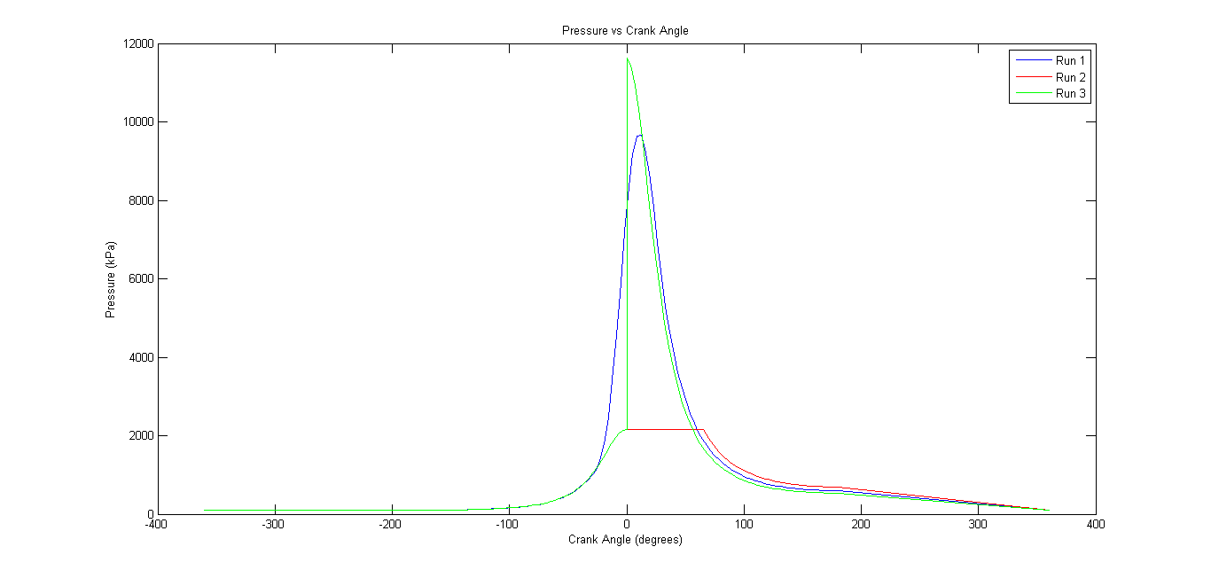

Figure 1 Pressure v/s crank angle for Constant volume (green), constant pressure (red) and finite burn duration (blue) cases

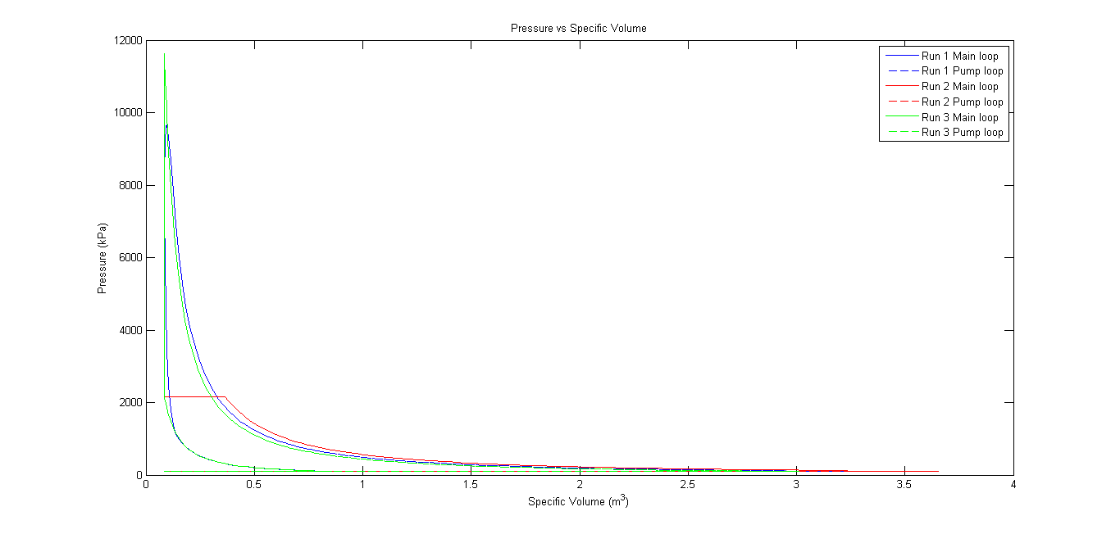

Figure 2 Pressure v/s volume for Constant volume (green), constant pressure (red) and finite burn duration (blue) cases

b. 3-4 : Fuel in these cycles is octane. Vaporization energy is completely provided by charge gas in case of cycle 4. Hence, cycle-4 has a lower air-fuel mixture temperature and pressure when compared to cycle-3. This is attributed to the additional sensible heat loss in air-residual mixture reducing its temperature. This also reduces the equilibrium temperature of air-fuel mixture. Thermal efficiency of cycle 4 is about 47% compared about 25% in case of cycle 3. As the pressure increase is higher in cycle 3, it generates more work and hence efficiency is higher. IMEP in case of cycle is also lower for the same reason.

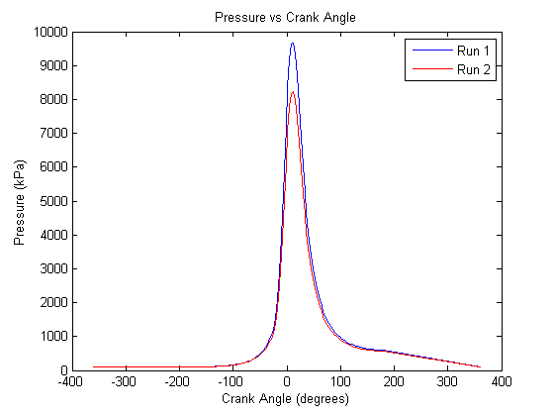

Figure 3 Pressure v/s crank angle for xfv=0(blue) and xfv=1(red)

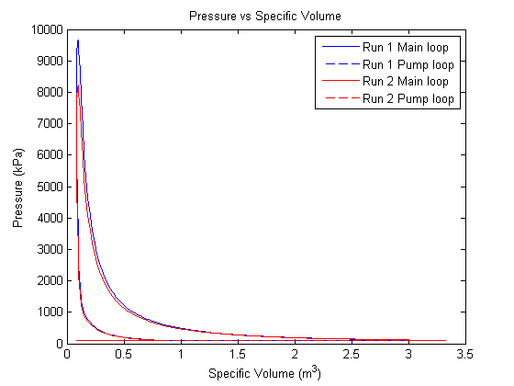

Figure 4 PV diagram for xfv=0 (Blue) and xfv=1 (Red)

c. 3-5 : Fuel in both the cases is n-Octane. But air in the second case has a relative humidity-RH value of 60%. Mass of air is calculated using this value and it is assumed that water is inert for the process of combustion. However, extra moles of water entering the cylinder increase the pressure. Hence pressure at state b in the case where there is humidity is higher. This also leads to slightly higher pressures and temperatures after compression. This also leads to a higher composite temperature. It is also evident that qin into the cylinder is lower because of the extra moles of water which reduce the heat supplied per unit mass of the charge – which in this case has higher charge. As the value of qin is lower in this case, the pressure after combustion is also lower leading max pressures of about 77bar which is much lower when compared to other values. This also has an impact on thermal efficiency which is lower in this case as the heat supplied is lower.

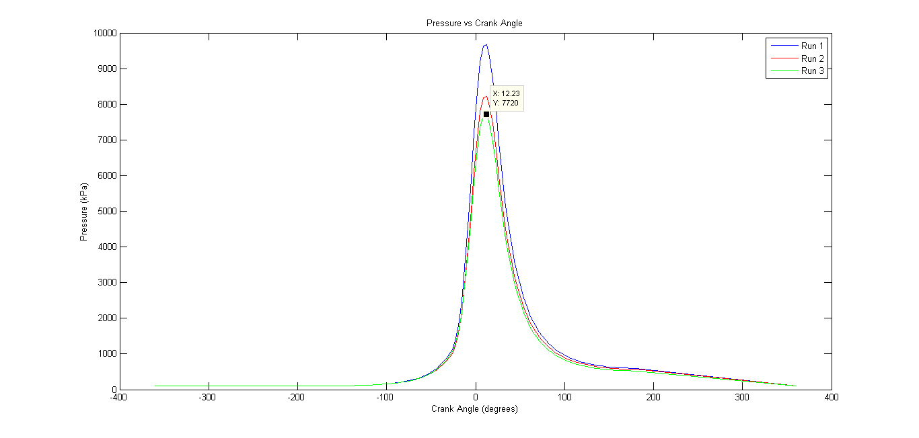

Figure 5 Pressure v/s crank angle for RH=0.6 (green) RH=0 (blue)

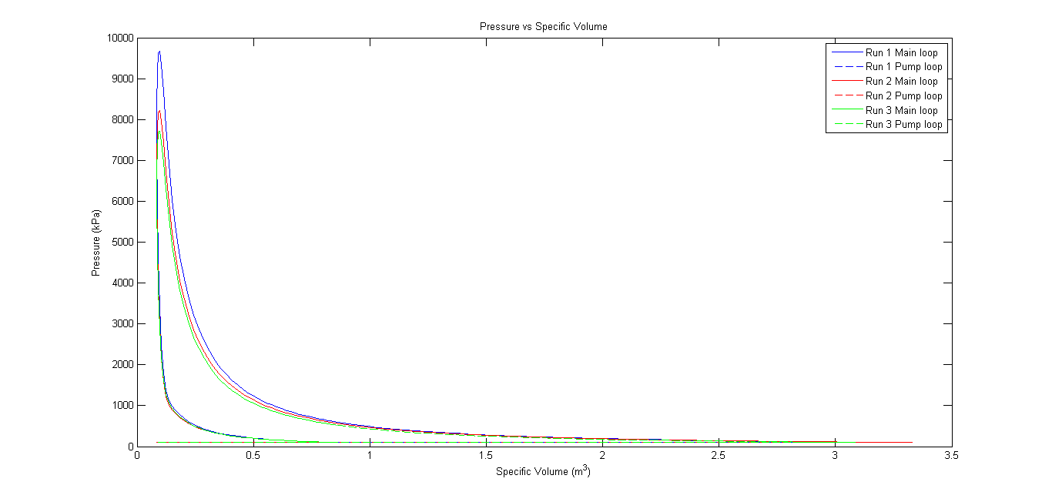

Figure 6 PV diagram when RH=0.6(green) RH=0(blue)

d. 3-4,6-7 : Fuel incase of 3-4 is octane and in case of 6-7 its ethanol. Ethanol has a lower LHV when compared to octane. Hence qin values of ethanol are lower when compared to octane. Heat of vaporization for ethanol is about 2.5 times higher when compared to octane. Hence when 100% heat of the charge gas is utilized, it is evident that lower temperatures and pressures are attained by the charge gas at state b. In case where energy of charge gas is not utilized, it is evident that thermal efficiency of octane is much higher at about 53% when compared to that of ethanol at about 45%. However, when heat is provided by the charge gas, trend reverses. As lower temperatures are attained before combustion, combustion process can transfer a larger heat value when compared to air-fuel mixture. Higher temperature gradient drives higher heat into the charge leading to a comparable efficiency despite lower heat input in case of ethanol

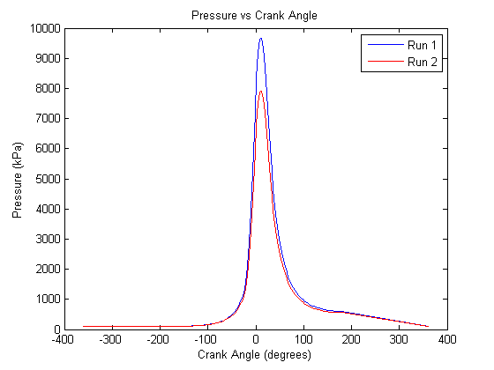

Figure 7 Pressure v/s crank angle n-octane (blue), ethanol (red) xfv=0

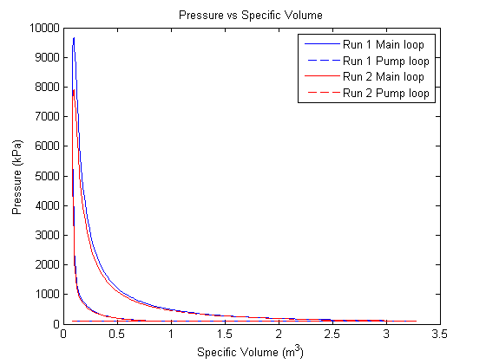

Figure 8 PV diagram n-octane (blue), ethanol (red) xfv=0

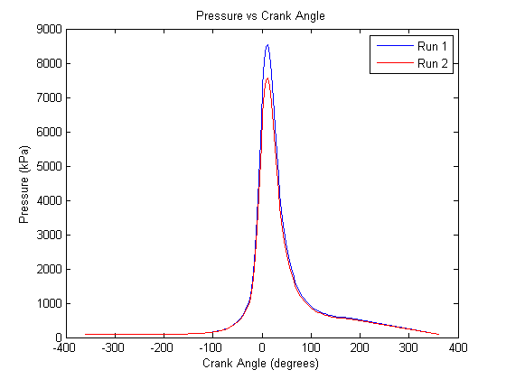

Figure 9 Pressure v/s crank angle n-octane (blue), ethanol (red) xfv=1

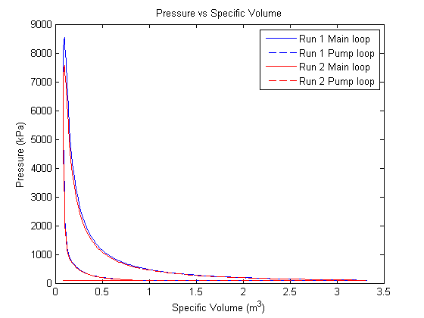

Figure 10 Pressure v/s crank angle n-octane (blue), ethanol (red) xfv=1

e. 3, 8-9: Fuel used in all the cases is n-Octane. Case 3 and 8 denotes a stochiometric air-fuel mixture whereas case 9 denotes a lean mixture with $ϕ=0.83$. It is evident that qin is lower in case of 8 when compared to 9. This is because of higher concentration of residual gases in case of 8 when compared to 3. However, in case of 9, qin is much lower this is because the mixture is lean and the value of Q/(mair+mresiduals+mfuel) is clearly much lower. MAP in case 9 is calculated from the imep of simulation 6. Pi/Pe values are solved for iteratively in ees so that higher qin is obtained matching the required imep values. It is notices at this point that imep is really a function of qin and Cp and Cv values do not play a major role in defining its value. Also, as the mixture is lean, Pi/Pe has to be higher so that more air is let into the cylinder which also makes higher quantities of fuel available so that a higher qin is obtained. Pi/Pe is set at 2.5 for obtaining the imep matching simulation 6. Comparing case 3 to 8 and 9, it can also be noticed that net imep and fuel conversion efficiency are different in this case because the inlet and ext pressures are not equal. Net imep incase of 8 lower when compared to case 3. This is because the exit pressure is twice that of the inlet pressure. However, in case of 9 net imep is higher because inlet pressure is twice that of the outlet pressure. Similar differences can be noticed in gross and net fuel conversion efficiencies.

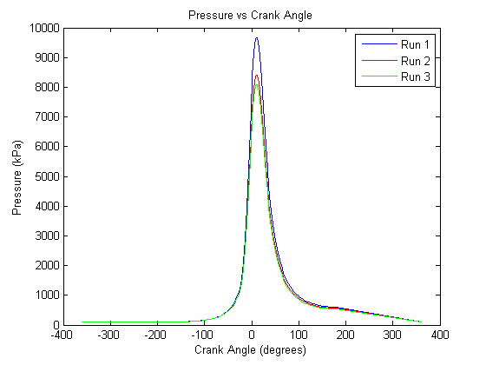

Figure 11 Pressure v/s crank angle for MAP=1 (Blue), 0.5 (Red), 2 (Green)

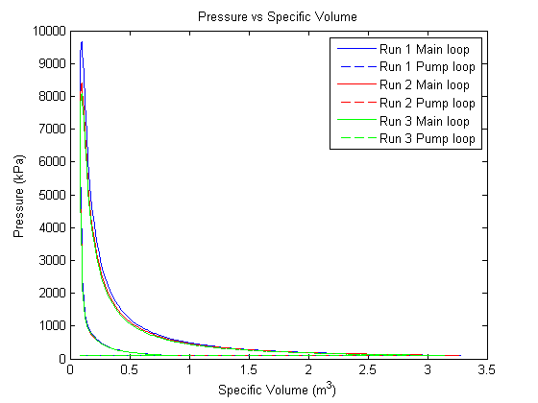

Figure 12 PV diagram for MAP=1 (Blue), 0.5 (Red), 2 (Green)

f. 3-10: Fuel in case of 3 and 10 are octane and methane respectively. Methane has a slightly higher Qlhv when compared to octane. qin for methane is evidently slightly higher at 2676 kJ/kg. Moreover, methane being a gas, has no heat of vaporization and hence charge gas temperatures is much higher at about 119C when compared to 105C in case of octane. This can be an apples-to-apples comparison as case 3 does not utilize charge gas sensible energy for vaporization. Despite higher heat input, thermal efficiency when methane is used is slightly lower when compared to the case octane is used as a fuel. This can be attributed to higher heat utilization by the gas in octane’s case as temperature if air-fuel mixture Tb is evidently lower. However, as Tb is higher to start with, temperature and pressure after compression is much higher in-case of methane. This results in higher imep values for methane fuel.

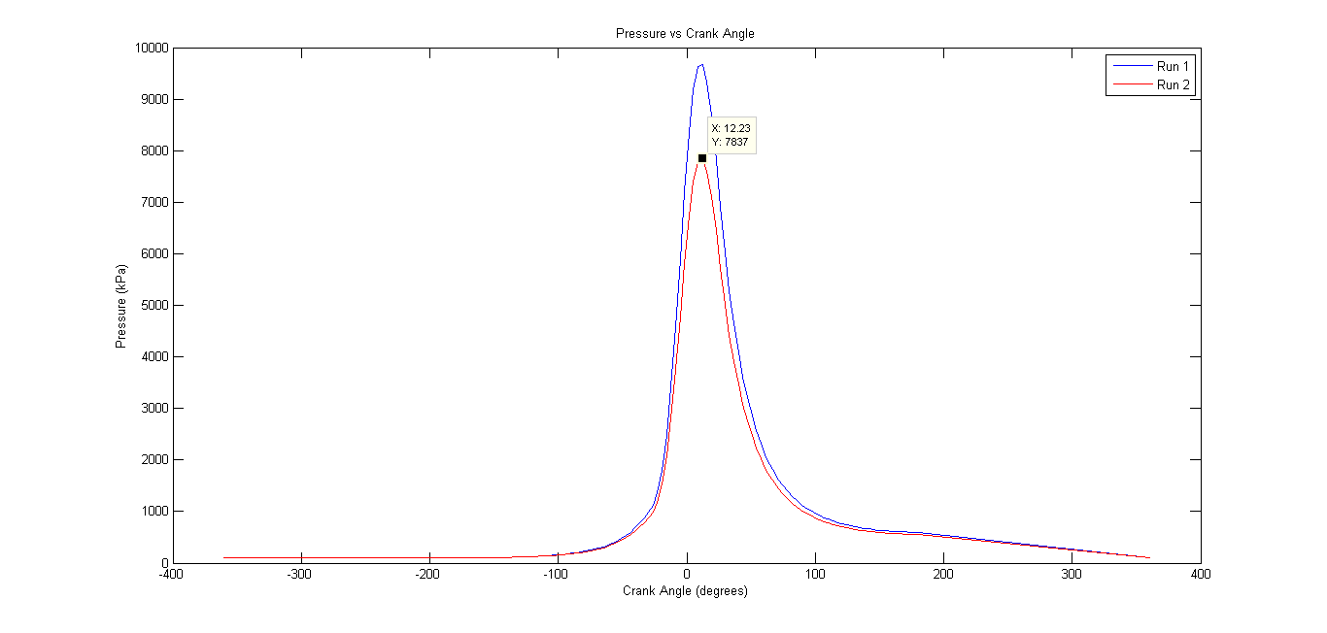

Figure 12 Pressure v/s crank angle diagram n-Octane (blue) and methane (red)

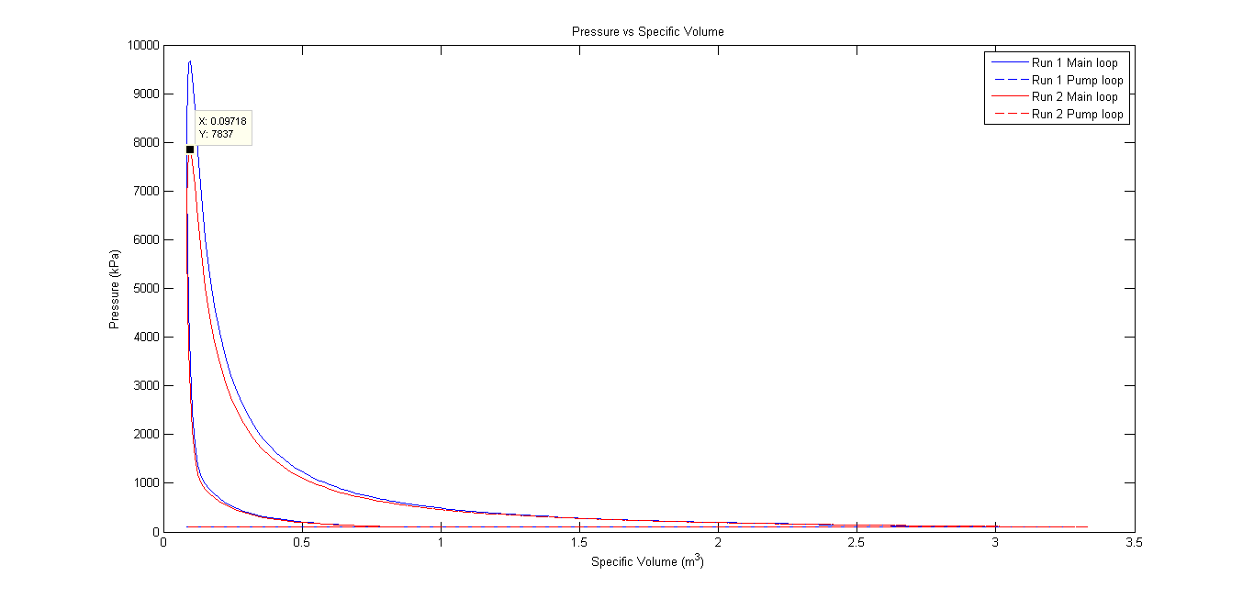

Figure 13 PV diagram for n-Octane (blue) and methane (red)

**Appendix A**

EES code used for solving case 1-9

"Solving for x_r and m_air"

T_amb = 298

T_amb_C = 25

P_amb =100

r_c = 10

p_i_e = 2.5

fuel$ = 'n-Octane'

T_r =1400 [K]

x_r = (1 + (T_r/T_amb)*(r_c*(p_i_e) - (p_i_e)^0.24))^(-1) {Calculation of fraction of gases trapped in the cylinder}

T_1 = T_r*r_c*x_r*p_i_e {Temperature of air + residuals}

V_air = (1/x_r)*1.01*V_r

V_air + V_r = 0.00369

m_air = 1.169*V_air

phi = 0 {Relative Humidity}

Psat = P_sat(Water,T=25) {Saturaion temperature}

omega = 0.622*phi*Psat/(100-phi*Psat) {Calculation of absolute humidity}

omega = m_h2o/m_air {Calculation of mass of water in air}

"Mass fraction of residuals and T_1_a"

{Octane}

"m_air = 0.0004413 "{mass of air from stoichiometry per g/mol of fuel}

"m_air = 0.00411"

m_air_rh = m_air + m_h2o

m_r = x_r*m_air + x_r*m_h2o

{Air to fuel ratios calcuated from stoichiometry}

{A_F_s = 9.01}{'Ethanol'}

A_F_s = 15.156 {n-Octane}

"A_F_s = 17.28" {Methane}

{Heat of vaporization}

h_v = 308 {n-Octane}

"h_v = 840"

{Fraction of heat from charge gas}

xfv = 0.8

{Calculating mmass of fuel, number of moles and Cv of fuel}

m_fuel = m_air/(A_F_s)

N_fuel = m_fuel/MolarMass(fuel$)

Cvfuel = Cv(fuel$,T= (T_1-273), P=100)

{Octane}

"X_air = 0.97

X_CO2 = 0.003

X_H2O = 0.0034

X_N2 = 0.018"

{Octane - pie - 0.5}

"X_air = 0.953

X_CO2 = 0.0058

X_H2O = 0.0066

X_N2 = 0.0346"

{Methane}

"X_air = 0.975

X_CO2 = 2.35*1e-3

X_H2O = 4.69*10e-3

X_N2 = 0.0176"

{Ethanol}

"X_air = 0.974

X_CO2 = 0.00313

X_H2O = 0.0046

X_N2 = 0.017"

{Octane with RH}

"X_air = 0.96

X_CO2 = 0.00295

X_H2O = 0.022

X_N2 = 0.017"

{Octane lean}

X_air = 0.98

X_CO2 = 0.0024

X_H2O = 0.0028

X_N2 = 0.0146

{Octane}

x_co2_p = 8/76.54

x_h2o_p = 9/76.54

x_n2_p = 47.16/76.54

{x_air_p = 12.38/76.54}

{Methane}

"x_co2_p = 1/10.546

x_h2o_p = 2/10.546

x_n2_p = 7.546/10.546"

M_wt_residuals = x_co2_p*44 + x_h2o_p*18 + x_n2_p*28 "+ x_air_p*28.96"

"First-law for vaporization"

Cv_air_mix = X_air*Cv(Air,T=T_1-273) + X_CO2*Cv(CO2,T=T_1-273) + X_H2O*Cv(Steam,T=T_1-273,X=1) + X_N2*Cv(N2,T=T_1-273)

xfv*m_fuel*h_v = (m_air/28.96+m_r/M_wt_residuals+ m_h2o/18 )*Cv_air_mix*(T_1 - T_b_1)

"First law for obtaining mixture temperature"

Cvfuel_b = Cv(fuel$,T=(T_b_1-273),P=100)

Cv_air_mix_b = X_air*Cv(Air,T=T_b_1-273) + X_CO2*Cv(CO2,T=T_b_1-273) + X_H2O*Cv(Steam,T=T_b_1-273,X=1) + X_N2*Cv(N2,T=T_b_1-273)

N_fuel*Cvfuel_b*(Tb - T_amb) = (m_air/28.96+m_r/M_wt_residuals+m_h2o/18)*Cv_air_mix_b*(T_b_1 - Tb)

"N_total = 0.0001544"

N_total = (m_air/28.96) + (m_fuel/MolarMass(fuel$)) + m_r/M_wt_residuals "+ m_h2o/18 "

P_b*0.00389 = N_total*8.314*Tb

Tb_C = Tb-273

x_air_af = (m_air/28.96)/N_total;

x_fuel_af = (m_fuel/MolarMass(fuel$))/N_total;

x_r_af = (m_r/M_wt_residuals)/N_total;

"x_h2o_af = (x_h2o/18)/N_total"

M_af = 28.96*x_air_af + MolarMass(fuel$)*x_fuel_af + M_wt_residuals*x_r_af "+ x_h2o_af*18"

S_sf_Tb = x_air_af*(entropy(Air,T=Tb_C,P=P_b)) + x_fuel_af*(entropy(fuel$,T=Tb_C,P=P_b)) + x_r_af*(x_co2_p*entropy(CO2,T=Tb_C,P=P_b) + x_h2o_p*entropy(Steam,T=Tb_C,P=P_b) + x_n2_p*entropy(N2,T=Tb_C,P=P_b "+ x_air_p*entropy(Air,T=Tb_C,P=P_b)"))"+ x_h2o_af*entropy(Steam,T=Tb_C,P=P_b)"

"Isentropic compression"

S_sf_Tc = S_sf_Tb

"Tc_C = 850"

P_c*(0.000039) = N_total*8.314*(Tc_C+273)

S_sf_Tc = x_air_af*(entropy(Air,T=Tc_C,P=P_c)) + x_fuel_af*(entropy(fuel$,T=Tc_C,P=P_c)) + x_r_af\***(**x_co2_p*entropy(CO2,T=Tc_C,P=P_c) + x_h2o_p*entropy(Steam,T=Tc_C,P=P_c) + x_n2_p*entropy(N2,T=Tc_C,P=P_c)"+x_air_p*entropy(Air,T=Tb_C,P=P_b)")"+x_h2o_af*entropy(Steam,T=Tc_C,P=P_c)"

{Calculation of composite temperature}

T_comp = (Tb_C + Tc_C)/2

{Calculation of gamma}

Cv_air_fuel = x_air_af*(Cv(Air,T=T_comp)) + x_fuel_af*(Cv(fuel$,T=T_comp,P=P_b)) + x_r_af\***(**x_co2_p*Cv(CO2,T=T_comp) + x_h2o_p*Cv(Steam,T=T_comp,P=P_b) + x_n2_p*Cv(N2,T=T_comp)"+x_air_p*Cv(Air,T=T_comp)") "+ x_h2o_af*Cv(Steam,T=T_comp,P=P_b)"

Cp_air_fuel = x_air_af*(Cp(Air,T=T_comp)) + x_fuel_af*(Cp(fuel$,T=T_comp,P=P_b)) + x_r_af*(x_co2_p*Cp(CO2,T=T_comp) + x_h2o_p*Cp(Steam,T=T_comp,P=P_b) + x_n2_p*Cp(N2,T=T_comp)"+x_air_p*Cp(Air,T=T_comp)")"+ x_h2o_af*Cp(Steam,T=T_comp,P=P_b)"

Cv = Cv_air_fuel/M_af

Cp = Cp_air_fuel/M_af

gamma_air_fuel = Cp_air_fuel/Cv_air_fuel

{Calculation of Qin}

{For OCtane}

q_in = (44.3*1e03)*m_fuel/(m_air_rh+m_fuel+m_r)

{Methane}

"q_in = (50*1e03)*m_fuel/(m_air_rh+m_fuel+m_r)"

{Calculation of theta0}

x_b = 0.5

theta = 8

dtheta = 50

m = 2

x_b = 1 - exp(-2.303*((theta-theta_0)/dtheta)^(m+1))

**Appendix B**

EES code used for solving real air stoichiometry

" Reference Conditions "

P_ref = 100 [kPa]

T_ref = 25.0 [C]

" Fuel Description "

" Mass fraction of components in fuel "

{ We'll normalized to factions in mole fractions }

EXX = 16; {Methane}

X_C = 75; { (%) kg/kg-total}

X_H = 25;

X_O = 0;

X_S = 0;

X_N = 0;

{ Define Air parameters here - Air data below }

Air_Hum_RH = 0/100; { Needs to be a fraction in function call}

lambda = 1.0;

"! "

"! ----------------------------------------"

"! Data "

" FUEL: Atomic Masses of fuel components "

MW_C = 12.011; {kg/kgmol}

MW_H = 1.008;

MW_O = 15.999;

MW_S = 32.07;

MW_N = 14.01;

" AIR: Molar Composition "

Y_Air_Dry_N2 = (780740+100)/1e6; { Here we will include the 100ppm of other}

Y_Air_Dry_O2 = 209430/1e6;

Y_Air_Dry_Ar = 9340/1e6;

Y_Air_Dry_CO2 = 390/1e6;

MW_Air_Dry = molarmass(N2)*Y_Air_Dry_N2 + molarmass(O2)*Y_Air_Dry_O2 + molarmass(Ar)*Y_Air_Dry_Ar + molarmass(CO2)*Y_Air_Dry_CO2;

"! "

"! ----------------------------------------"

"! Solution "

" AIR "

" First compute parameters for moist air "

omega = humrat(AIRH2O, P=P_ref, T=T_ref, R=Air_Hum_RH);

Air_Hum_RH_Check = relhum(AIRH2O, P=P_ref, T=T_ref, w=omega);

N_Air_Dry_H2O = 1.608*omega { Moles of water per mole of dry air }

" Compute moles of consistuents in air per mole of O2 "

" These are exactly the coefficients in our real air "

" themochemisty equation "

foo = 1/Y_Air_Dry_O2; { This should be 4.775 - consistency check }

N_O2_H2O = foo*N_Air_Dry_H2O;

N_O2_N2 = foo*Y_Air_Dry_N2;

N_O2_Ar = foo*Y_Air_Dry_Ar;

N_O2_CO2 = foo*Y_Air_Dry_CO2;

N_O2_O2 = foo*Y_Air_Dry_O2;

" Now compute Moist Air Mole fractions "

N_Air_Wet_Total = 1+N_Air_Dry_H2O;

Y_Air_Wet_N2 = Y_Air_Dry_N2 /N_Air_Wet_Total;

Y_Air_Wet_O2 = Y_Air_Dry_O2 /N_Air_Wet_Total;

Y_Air_Wet_Ar = Y_Air_Dry_Ar /N_Air_Wet_Total;

Y_Air_Wet_CO2 = Y_Air_Dry_CO2/N_Air_Wet_Total;

Y_Air_Wet_H2O = N_Air_Dry_H2O/N_Air_Wet_Total;

SUM_CHECK_1 = Y_Air_Wet_N2 + Y_Air_Wet_O2 + Y_Air_Wet_Ar + Y_Air_Wet_CO2 + Y_Air_Wet_H2O;

MW_Air_Wet = Y_Air_Wet_N2 *molarmass(N2) + Y_Air_Wet_O2 *molarmass(O2) &

+ Y_Air_Wet_Ar *molarmass(Ar) + Y_Air_Wet_CO2*molarmass(CO2) + Y_Air_Wet_H2O*molarmass(H2O);

" FUEL "

" Convert from mass fractions to mole fractions "

Mole_Sum = X_C/MW_C + X_H/MW_H + X_O/MW_O + X_S/MW_S + X_N/MW_N;

Y_C = (X_C/MW_C) / Mole_Sum;

Y_H = (X_H/MW_H) / Mole_Sum;

Y_O = (X_O/MW_O) / Mole_Sum;

Y_S = (X_S/MW_S) / Mole_Sum;

Y_N = (X_N/MW_N) / Mole_Sum;

" Compute Fuel Atomic Ratios used to describe C1 fuel model "

HCR = Y_H/Y_C;

OCR = Y_O/Y_C;

SCR = Y_S/Y_C;

NCR = Y_N/Y_C;

" Thermochemistry reaction coefficient for C1 Fuel "

R = 1 + HCR/4 - OCR/2 + SCR + NCR/2

" Molecular Weight of C1_Fuel "

MW_F = MW_C + MW_H*HCR + MW_O*OCR + MW_S*SCR + MW_N*NCR

"! Now work-out fuel air stoichiometry with Ideal Air"

AFR_Air_Dry_Stoich = (R*4.773*28.97) / MW_F

AFR_Air_Dry_Lambda = lambda*AFR_Air_Dry_Stoich

"! Now work-out fuel air stoichiometry with Real Air without humidity"

AFR_AirReal_Dry_Stoich = (R*1/Y_Air_Dry_O2*28.965) / MW_F

AFR_AirReal_Dry_Lambda = lambda*AFR_AirReal_Dry_Stoich

**Grade Sheet**

Student: Arjun Darbha

|  |  |  |
| --- | --- | --- |
| **Area** | **Points** | **Score** |
| Cover Sheet | 5 |  |
| Part I | 20 |  |
| Part II | 20 |  |
| Part III | 30 |  |
| Code properly documented and formatted | 20 |  |
| Report format | 5 |  |
| **Total =** | **100** |  |

**End of document**